SOCIAL POST #1 – SCHEDULE VACCINES FOR YOUR CHILDREN
FACEBOOK – Download the image to copy and upload to your Facebook page with the suggested copy.

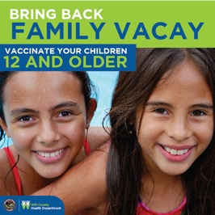

TEXT LANGUAGE:
Will County Health Department’s COVID-19 vaccination sites are now open to children ages 12 to 15 for the two-dose Pfizer vaccine. Previously, only age 16 and older could receive the vaccine.

All minors under 18 must have a parent or legal guardian present during their appointment who must remain with the child throughout the entire visit.

Children ages 12-17 may only receive the Pfizer vaccine which has been approved by the FDA and CDC.

If a parent or legal guardian is unable to accompany their child to a clinic run by Will County Health Department, their child can still receive a vaccine if:
  - The minor is accompanied by someone over the age of 18 designated by their parent or legal guardian, and
  - The minor brings the consent FORM signed by their parent or legal guardian.

Find your Pfizer Vaccine Clinic at our online scheduling portal at www.willcountyhealth.org

or call 815-774-7386 to schedule an appointment.

SOCIAL POST #2 – VACCINES FOR HOMEBOUND
FACEBOOK – Download the image to copy and upload to your Facebook page with the suggested copy.

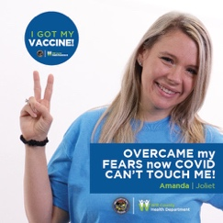

TEXTLANGUAGE:
Do you know someone who is interested in receiving a COVID-19 vaccine who is unable to get out of the house due to medical limitations?
Consider applying for our homebound vaccination program through the Will County Health Department! Click the link to apply, and we will follow up with you as soon as we can! We want to get everyone vaccinated, especially those who are most at-risk and homebound.
TAKE OUR SURVEY https://www.surveymonkey.com/r/3R8ZFNT

SPANISH TEXT LANGUAGE:
¿Conoce a alguien que tenga interés en recibir una vacuna contra COVID-19 y no pueda salir de su hogar debido a limitaciones médicas? ¡Considere postularse para nuestro programa de vacunación para personas confinadas en su hogar a través del Departamento de Salud del Condado de Will! ¡Haga clic en el enlace para postularse y nos pondremos en contacto con usted tan pronto como podamos! Queremos que se vacunen todas las personas, especialmente aquellas que corren mayores riesgos y que están confinadas en su hogar.

Formulario de contacto del condado de Will para la vacunación contra COVID-19 a domicilio: https://www.surveymonkey.com/r/SLNS3TF

