SOCIAL POST #1 – SCHEDULE VACCINE PROMOTION:
FACEBOOK – Download images in zip file and use for your social posts or copy the image below and upload to your Facebook page.
IMAGE:
TEXT LANGUAGE:
The Will County Health Department moved to open scheduling on Monday, April 12th as Will County moved to Phase 2 - allowing universal eligibility for residents 16 and older.
As such, Will County residents over the age of 16 will now be able to directly schedule vaccine appointments online at www.willcountyhealth.org. Residents will no longer have to register with the health department to schedule a vaccine.
Will County Health Department runs five open vaccination sites including:
- Will County Health Department at 501 Ella Avenue, Joliet
- Former Toys R Us at 3128 Voyager Lane, Joliet
- Joliet West High School, run by the Joliet Fire Department at 401 N Larkin Ave, Joliet
- St. Rose School, 626 S Kankakee St, Wilmington
- Vaccine Clinic at 6370 Emerald Parkway, Monee
In addition, there are 60 additional locations in Will County that are providing vaccine appointments including Walgreens, Jewel-Osco, Meijer, Mariano’s, Oak Street Health, and Aunt Martha’s. All locations can be found at www.willcountyhealth.org
TWITTER
Everyone over age 16 is now eligible to schedule your vaccine with the Will County Health Department. Just log onto www.willcountyhealth.org to schedule your vaccine today.

SOCIAL POST #2 – BE SAFE POST:
FACEBOOK – Download images in zip file and use for your social posts or copy the image below and upload to your Facebook page.
IMAGE:
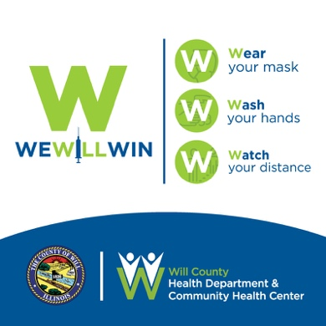
TEXT LANGUAGE:
As we make progress on vaccinating our residents and workers, we must remain dedicated to practicing COVID-19 safety measures. As of April 9th, only 16% of our population has been fully vaccinated.
During the past several weeks, we have seen an uptick in positive COVID-19 cases. We must curb this increase in order to avoid any rollbacks and another wave of COVID-19.
Please continue to practice the three W’s so that we can all WIN!
- Wash your Hands
- Wear your Mask
- Watch your Distance

Together we can defeat Covid-19 and keep moving forward.

TWITTER
VACCINES + COVID 19 SAFETY = HAPPY, HEALTHY & SAFE LIVING. Schedule your Vaccine, Wash your Hands, Wear your Mask and Watch your Distance. Learn more. www.willcountyhealth.org

SOCIAL POST #3 – SCHEDULING PHONE LINE:
FACEBOOK – Download images in zip file and use for your social posts or copy the image below and upload to your Facebook page.
IMAGE:
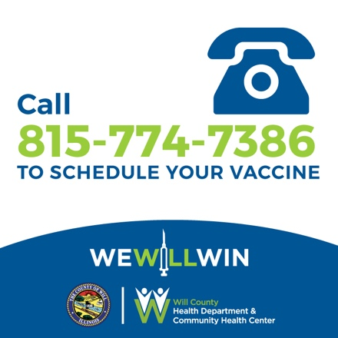
TEXT LANGUAGE:
Are you having trouble scheduling your vaccine online and want to talk to a representative to schedule your appointment?

The Will County Health Department is now offering scheduling to Vaccine Clinics through their COVID-19 appointment scheduling phone line - 815-774-7386
It is open Monday thru Friday from 8:00 AM to 4:00 PM. The experienced team of professionals is eagerly waiting your calls to assist you in scheduling your vaccine. Please keep in mind that the best way to schedule an appointment is online at willcountyhealth.org which is available 24/7/. Please use this phone line only if you are experiencing technical difficulties.
For complete information on COVID-19 vaccinations, clinics, recommendations and the latest news visit www.willcountyhealth.org.

TWITTER
Are you having trouble scheduling your vaccine online and want to talk to a representative to schedule your appointment? Call the Will County Health Vaccine Line 815.774-7386 (M-F, 8A-4P)

